**Experiment: 8**

**Student Name: Rishav Kumar UID: 22MCC20039**

**Branch: MCA - CCD Section/Group: 22MCD1 / Grp A**

**Semester: II Date of Performance: 4th May 2023**

**Subject Name: Software Testing Subject Code: 22CAH-685**

**Q. What is Epic?**

An epic is a high-level user story or a large feature that can be broken down into smaller, more manageable tasks or user stories. Epics help to organize and group related issues together. Bugs, on the other hand, are issues that describe problems or defects in the software. Here are the steps to create an epic and a bug in Jira:

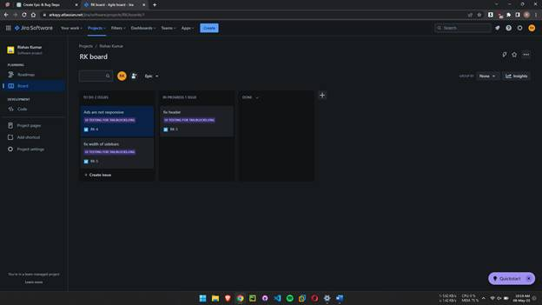

**Creating an Epic:**

1.      Log in to your Jira account and navigate to your desired project.

2.      Click on the "Create" button, usually located in the top-left corner of the Jira interface.

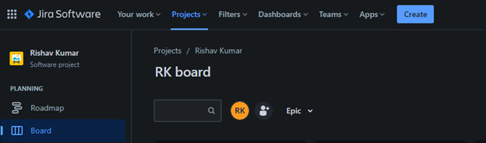

3.      In the issue creation screen, select the issue type as "Epic." This option is usually available in a drop-down list or as a button.

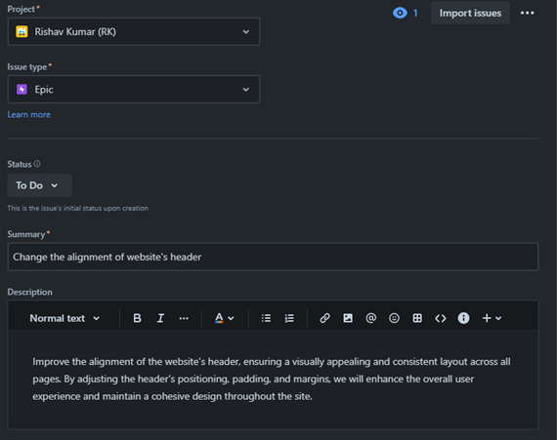

4.      Fill in the required fields, such as Summary (a brief title for the epic) and Description (a detailed description of the epic).

5.      Optionally, you can add more details, such as Assignee (the person responsible for the epic) and Labels (to categorize the epic).

6.      Click on the "Create" or "Submit" button to create the epic. It will be added to your project's issue list.

**Creating a Bug:**

1.      Log in to your Jira account and navigate to your desired project.

2.      Click on the "Create" button.

3.      In the issue creation screen, select the issue type as Bug.

4.      Fill in the required fields, such as Summary (a concise title describing the bug) and Description (a detailed explanation of the bug).

5.      Optionally, provide additional information, such as Steps to Reproduce (how to recreate the bug) and Expected Results (what the expected behavior should be).

6.      You can also assign the bug to a specific Assignee, set a Priority level, and add Labels for better organization.

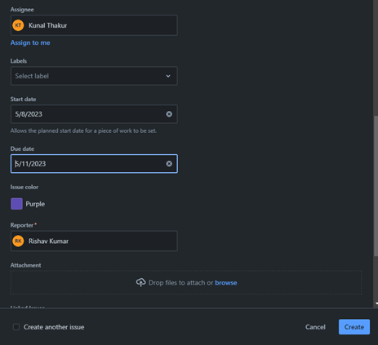

7.      Attach any relevant files or screenshots to provide more context if necessary.

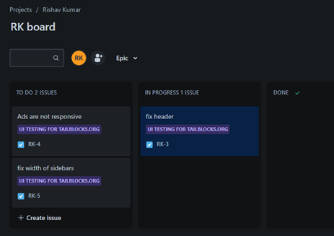

8.      Click on the "Create" or "Submit" button to create the bug. It will be added to your project's issue list.